DAD 220 Project Two Template

Overview
Review the scenario for this activity in the guidelines and rubric. Then complete the steps below as you work through the directions for this activity. Replace the bracketed text with your screenshots and responses to the prompts. Size each screenshot and its explanation to fit approximately one-quarter of the page with the description written below the screenshot. Review the Template Screenshot Example linked in the guidelines and rubric for this assignment to see an example of how screenshots for your assignment should look.

RMA Report
Write a report to respond to the manager’s requests. In the report, you should complete the following actions:

- Summarize the data you’ve been working with.
- Identify key information that will help the company streamline operations.

Your report should explain your findings in a way nontechnical stakeholders can understand and use.

Use the steps below to capture the required data and produce the analysis report.

- Begin by writing SQL commands to capture specific usable data for your analysis. You already preloaded the data you need into Codio.
- Specifically, the product manager wants you to complete the following analysis:

  - Analyze the number of returns by state and describe findings to include in your report.

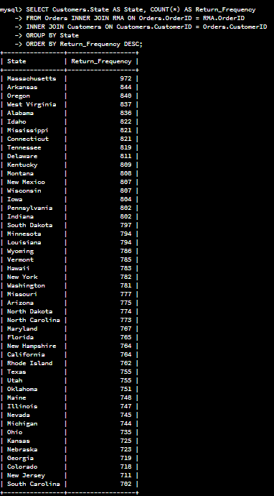
This shows that certain states have higher return frequencies, which may indicate issues in product distribution or customer service in those states
States with the most returns: (Massachusetts, Arkansas, Oregan)
States with the least returns: (South Carolina, New Jersey, Colorado)
  - Analyze the percentage of returns by product type and describe findings to include in your report.

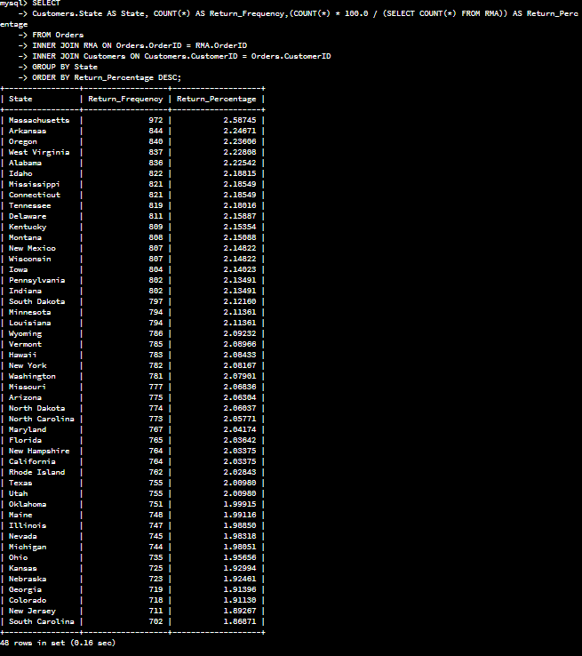
From what is shown here it shows both the percentage and frequency of returns which is the same as the states I’ve stated in the previous question.
- Write a report to clearly summarize your RMA data analysis for stakeholders. When you summarize the results, consider the following questions:

  - How does the data provide the product manager with usable information?
  - What are the potential flaws in the data that has been presented?
  - Are there any limitations on your conclusions or any other ways of looking at your findings that you haven’t considered? Clearly communicate your findings to stakeholders.

The data provided gives the product manager usable information because it shows geographic trends, the states with high returns could benefit from targeted process improvements, such as improving the accuracy of shipped products or better customer service. It also shows product insights, prioritizing improvements for the most frequently returned products can enhance customer satisfaction and reduce return rates.
The flaws I’ve seen in the data shown is lack of data completeness, such as, missing records. I’ve also seen gaps in context because the dataset doesn’t include reasons for returns, which limits the ability to identify root causes.
Limitations in my conclusions include seasonal data, or, which product is sold the most according to season, which is not shown in this dataset. Also additional feedback such as customer feedback and product defect rates which would improve the quality of this analysis and would be beneficial to the product manager.

